

**Tribhuvan University**

**Faculty of Humanities and Social Sciences**

**A PROJECT REPORT**

**On**

**Online Music Streaming Platform**

**Submitted to**

**Department of Computer Application**

**Ratna Rajya Laxmi Campus**

**In partial fulfillment of the requirements for the Bachelors in Computer Application**

**Submitted by**

**Rahul B.K**

**Reg no: 6-2-40-30-2021**

**Preshuk Luitel**

**Reg no: 6-2-40-29-2021**

**22 March,2024**

**Under the Supervision of**

**Mr. Aananda K.C**



**Tribhuvan University**

**Faculty of Humanities and Social Sciences**

**Ratna Rajya Laxmi Campus**

**Supervisor’s Recommendation**

I hereby recommend that this project prepared under my supervision by **RAHUL B.K** and **PRESHUK LUITEL** entitled “**ONLINE MUSIC STREAMING PLATFORM**” in partial fulfillment of the requirements for the degree of Bachelor of Computer Application is recommended for the final evaluation.

**______________________**

**Mr. Aananda K.C**

**SUPERVISOR**

**Department of Computer Application**

**Pradarshani Marg, Kathmandu**



**Tribhuvan University**

**Faculty of Humanities and Social Sciences**

**Ratna Rajya Laxmi Campus**

# LETTER OF APPROVAL

This is to certify that this project prepared by **RAHUL B.K** and **PRESHUK LUITEL** entitled “**ONLINE MUSIC STREAMING PLATFORM**” in partial fulfillment of the requirements for the degree of Bachelor in Computer Application has been evaluated. In our opinion it is satisfactory in the scope and quality as a project for the required degree.

|  |  |
| --- | --- |
| **__________________**  Mr. Aananda K.C  Lecturer, BCA  Department of Computer Application Pradarshani Marg, Kathmandu | **___________________**  Mr. Bhupendra Ram Luhar  Coordinator, BCA  Department of Computer Application Pradarshani Marg, Kathmandu |
| **________________**  Internal Examiner | **________________**  External Examiner |

# ACKNOWLEDGEMENT

The project work presented in this report has been carried out and presented at Ratna Rajya Laxmi Campus, Faculty of Humanities and Social Sciences Tribhuvan University of Technology as a part of Bachelors of Arts in Computer Application. Project is a test of not only technical skills but also team work and performance under various constraints. This journey cannot be successfully accomplished without help from experts.

Furthermore, we would like to thank our lecturers of the Department of Computer Application for their kindness in sharing their knowledge with us which in different ways has helped us in coming up with this project and being there for us when we needed them, our friends who have always been there to support us and our respondents who gave us feedbacks on improving our project work.

We will be ever grateful to our supervisor **Mr. Aananda K.C**, Lecturer without whose guidance, this project would not have become successful.

We are also grateful to our department coordinator **Mr. Bhupendra Ram Luhar**.

Finally, our greatest appreciation and love goes to our families, friends and mentors and for sure this would not have happened without their unconditional love, care and support.

# ABSTRACT

The Online Music Streaming Platform (OMSP) documentation presents a comprehensive system tailored for music enthusiasts, artists, and creators alike. Central to its functionality is the ability for users to effortlessly upload their music, fostering a vibrant community where artists can share their creations with a global audience. Through the intuitive upload feature, users can seamlessly contribute their songs, fostering collaboration and creativity within the platform.

OMSP offers an immersive social experience through its dynamic Feed feature, where users can engage with a diverse range of music content. With options to like, dislike and comment the Feed facilitates meaningful interactions, allowing users to discover new music and connect with fellow enthusiasts. Additionally, the platform's integrated chat system enables real-time communication, empowering artists to collaborate, exchange ideas, and foster connections within the vibrant community.

Moreover, OMSP provides users with personalized experiences through customizable user profiles and insightful dashboards. By creating detailed user profiles, individuals can curate their presence within the platform, sharing their music preferences and connecting with like-minded peers. The dashboard offers comprehensive insights into the platform's ecosystem, presenting users with detailed statistics on songs, albums, plays, users, artists, playlists, and more. Through these features, OMSP aims to cultivate a thriving online music community, empowering users to explore, create, and connect in a dynamic digital landscape.

**Table of Contents**

LETTER OF APPROVAL 2

ACKNOWLEDGEMENT 3

ABSTRACT 4

Chapter 1: Introduction 7

1.1. Introduction 7

1.2. Problem Statement 8

1.4. Scope and Limitation 9

1.5. Report Organization 9

Chapter 2: Background Study and Literature Review 10

Chapter 3: System Analysis and Design 13

3.1. System Analysis 13

3.1.1. Requirement Analysis 13

3.1.2. Feasibility Study 14

3.2.3. System Design 16

3.2.1. Architectural Design 16

3.2.2. Database Schema Design 17

3.2.4. Interface Design (UI Interface / Interface Structure Diagrams) 18

3.2.5. Data Modeling using ER Diagram 20

3.2.6. Process Modeling using DFD 20

3.2.7. Physical DFD 22

Chapter 4: Implementation and Testing 23

4.1. Implementation 23

4.1.1. Tool Used 23

4.1.2. Implementation Details of Modules 24

4.2. Testing 24

4.2.1 Test Case for Unit Testing 25

Conclusion 27

References 28

**List of Figures :**

Figure 1 Use Case Diagram of Online Music Streaming Platform 13

Figure 2 Gantt Chart of OMSP 15

Figure 3 Architectural Design of OMSP 16

Figure 4 Database Schema Design of OMSP 17

Figure 5 Homepage 18

Figure 6 Index Login Page of OMSP 18

Figure 7 Login form 19

Figure 8 ER Diagram of Music Streaming Site 20

Figure 9 Level 0 dfd of Music Streaming Site 21

Figure 10 Level 1 DFD of OMSP 22

# 

# Chapter 1: Introduction

## 1.1. Introduction

Welcome to our Online Music Streaming Platform, your ultimate destination for sharing, discovering, and collaborating on musical creations! With our platform, users can upload their own music effortlessly, sharing their creations with other artists and users worldwide. Whether you're a budding musician looking to showcase your talent or an avid music lover seeking new sounds, our upload feature provides a seamless experience to share your music with the world.

Explore a vibrant community of music enthusiasts through our interactive Feed feature. Discover a diverse range of songs from fellow users, where you can express your appreciation by liking, commenting, or even collaborating with other artists. Our platform fosters connections and creativity through a dynamic environment where users can engage with each other and explore new musical horizons.

Create your personalized User Profile to curate your musical journey. Fill in your details, showcase your favorite tracks, and connect with like-minded individuals. Keep track of your musical activity and engage with our comprehensive Dashboard, offering detailed statistics on songs, albums, plays, users, and much more. Our platform is designed to empower users, whether they're artists seeking recognition or music enthusiasts craving new experiences. Additionally, website content management allow admin to add or delete details and information of New songs updates. [1].

With this Online Music Streaming Platform, users can update their songs with their own taste of music and collab with different artists.[2].

## 1.2. Problem Statement

In today's dynamic world, online music streaming platforms have seen remarkable growth, yet opportunities for innovation remain untapped. While current platforms offer abundant content, the lack of interactivity and service issues leave users seeking a more engaging experience. Recognizing these challenges, there's a need for a paradigm shift in online music streaming, addressing shortcomings and enhancing user engagement.

A key challenge lies in the limited music exploration features of existing platforms, hindering an immersive user experience. In an era of evolving musical landscapes, users desire more than passive listening—they crave platforms that understand their diverse tastes and involve them in the music discovery process.

Our proposed online music streaming platform acknowledges these gaps and leverages advanced technologies to bridge them. Picture a platform not just for streaming, but also fostering a community-driven atmosphere where users collaboratively share and discover new tracks, remixes, and playlists.

1.3. Objectives

The main objectives of this system are as follow:

∙ To develop a platform that Enhance User Engagement through Interactive Features.

∙ Facilitate easy sharing of user-generated content, encouraging artists to showcase their work and build a dedicated fan base.

∙ To provide Virtual Experiences and Global Collaboration

∙ To store a proper computerized database of Music Content and registered users.

## 1.4. Scope and Limitation

Scope:

The Online Music Streaming Platform aims to provide a user-friendly online platform for Music Listeners and Content Creators. It includes features such as browsing and searching for Songs along with the user’s according genre, playlist and conversation with the admin or an artist . This also includes user panel management, and administration functionalities.

Limitation:

The system has limitations in terms of scalability for handling a large number of users and inventory. It may not be fully optimized for mobile devices and lacks localization options. External integration capabilities may be limited, and dedicated technical support may not be available. While efforts have been made for collaborating features along with artist’s choice following process, there may still be potential vulnerabilities. Requiring users to adapt to predefined features and workflows.

## 1.5. Report Organization

The report can be organized into 5 chapters which are given below:

**Chapter 1** includes introduction includes the brief introduction of the system, statement of problem, objectives, scope and limitation.

**Chapter 2** includes background study and literature review includes the previous work related to the systems and similar works were studied and are summarized.

**Chapter 3** includes system analysis and design includes different feasibility analysis and designed system architecture, system flow diagram, dataflow diagram.

**Chapter 4** includes implementation and testing includes various implementation method and tools and also contains description of testing.

**Chapter 5** includes conclusion and future recommendations includes outcomes of the system, conclusion to the system and description about what features can be added in the future.

Chapter 2: Background Study and Literature Review2.1. Background Study

The Online Music Streaming Platform requires a comprehensive understanding of fundamental theories, general concepts, and terminologies related to Music experience and User Creativity. This background study provides an overview of key concepts relevant to the project.

**Music Industry Dynamics**: Understanding the music industry landscape is crucial. This involves studying the structure of the music industry, including record labels, independent artists, licensing agreements, and copyright laws. An overview of revenue streams in the music industry, such as streaming, downloads, and live performances, is also essential. This background study helps in comprehending the ecosystem in which the online music streaming platform operates.

**Digital Media Technologies:** Familiarity with digital media technologies is necessary to grasp the technical aspects of streaming platforms. This includes knowledge of audio codecs, streaming protocols, digital rights management (DRM), and content delivery networks (CDNs). Understanding these technologies is vital for ensuring smooth playback, maintaining audio quality, and protecting intellectual property rights.

**User Experience (UX) Design**: User experience design principles play a significant role in creating an engaging and intuitive platform. Studying UX design involves exploring concepts such as user interface (UI) design, information architecture, usability testing, and user feedback mechanisms. By understanding user behaviors and preferences, designers can create interfaces that are easy to navigate and visually appealing, enhancing user satisfaction and retention.

**User Registration and Authentication**: User registration is the process by which users create an account on a website or platform. It typically involves providing personal information and creating login credentials. Authentication is the verification of user credentials to grant access to specific features or resources within the system. User registration and authentication ensure secure access to the system and personalized user experiences.

**Legal and Licensing Framework**: Ensuring legal compliance is vital for online music streaming platforms. This includes understanding copyright laws and securing licensing agreements with music labels and publishers. Adhering to these regulations ensures ethical content usage and fair compensation for artists, maintaining the platform's integrity within intellectual property boundaries.

**Content Curation and Management**: Curating and managing a vast library of music content is central to the success of an online music streaming platform. This involves studying methods for organizing and categorizing music content, including genres, artists, albums, and playlists. Understanding metadata standards, such as ID3 tags and music metadata schemas, is essential for accurately cataloging and retrieving music tracks. Additionally, exploring content moderation techniques and copyright infringement detection mechanisms helps ensure that the platform maintains a high-quality and legally compliant content library.

**Social and Community Features**: Integrating social and community features boosts user engagement and cultivates a sense of community. This entails grasping concepts like user profiles, social media integration, follower systems, and user-generated content (UGC). Tools such as forums, discussion boards, and collaborative playlist creation foster interaction and collaboration, enhancing the music discovery and listening journey for users.

**Database Management**: Database management involves the organization, storage, and retrieval of data within a database system. It includes tasks such as designing database schemas, creating tables, defining relationships, and querying data. Database management ensures efficient data storage and retrieval for the (OMSP).

Understanding these fundamental theories, general concepts, and terminologies is essential for developing a robust and effective (OMSP). They provide the access to the users make their own taste of music, upload their own creations.

2.2. Literature Review

The literature on online music streaming platforms reveals a diverse landscape of platforms with varying features and functionalities. Several existing platforms have been studied, providing insights into their effectiveness in delivering music content and engaging users. For instance, platforms like Spotify, Apple Music, and YouTube Music offer vast music libraries, personalized recommendations, and user-friendly interfaces, making them popular choices among music enthusiasts [1]. These platforms utilize advanced algorithms to analyze user preferences and behaviors, enhancing the music discovery experience and fostering user engagement.

User experience emerges as a key theme in the literature, emphasizing the importance of intuitive interfaces and seamless navigation. Research indicates that platforms with clutter-free designs and easy-to-use features tend to attract and retain more users [2]. Additionally, studies highlight the significance of interactive features such as playlist creation, social sharing, and collaborative music discovery tools in enhancing user satisfaction and loyalty [1].

Moreover, the literature underscores the role of technology in shaping the evolution of online music streaming platforms. Advancements in streaming protocols, audio compression algorithms, and cloud infrastructure have revolutionized the way music is distributed and consumed [3]. Platforms leverage these technologies to deliver high-quality audio streaming, minimize buffering times, and provide offline playback options, enhancing the overall user experience.

# Chapter 3: System Analysis and Design

## 3.1. System Analysis

Requirement collection provides detailed analysis of user requirements, functional & non-functional requirement and system requirement. The front-end is done using HTML&CSS whereas in back-end JavaScript is used for Client side and PHP for Server side. MySQL is used for Database programming.

## 3.1.1. Requirement Analysis

**i. Functional Requirement**

The Use Case Diagram of the system (Online Music Streaming Platform) is given: 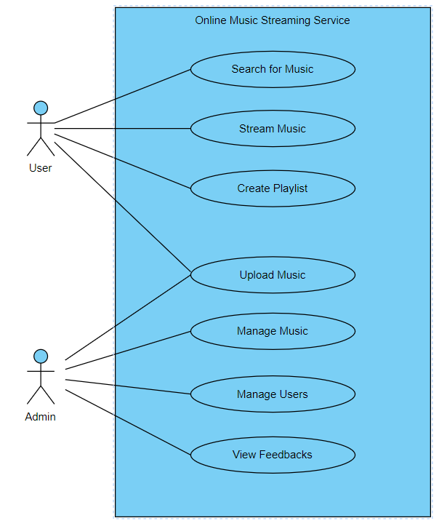

Figure 1 Use Case Diagram of Online Music Streaming Platform

**For User**:

∙ User can register and create an account.

∙ Secure login functionality for customer access.

∙ Customers can browse and search for Music According to their taste. ∙ Users can upload to their music content and Create a log of genre . Secure their content with options like private, public for upload.

**For Admin**:

∙ Admin can securely log in and log out of the system.

∙ Admin can add, delete, and update new tending music.

∙ Admin can monitor and manage customer information.

∙ Admin can handle and process of collaboration and exploration for fresh content. ∙ Admin can securely view and update all the copyrights free music.

**ii. Non-functional Requirement**

The system has form-based interface for data entry and stores reports in formatted in a table and for user friendliness. The system has reasonable short time response. The system has good performance as response time is short. The system doesn’t crash in middle of process as it is reliable. System can be considered secure as only admin can view user’s information.

## 3.1.2. Feasibility Study

**i. Technical Feasibility**

Since the project is design with PHP as code behind and MySQL as backend it is easy to install in the systems whenever needed. It is more efficient, easy and user friendly to understand by almost everyone. Huge amount of data can be handled efficiently using MySQL as backend. Hence this project has good technical feasibility*.*

**ii. Operational Feasibility**

The system is operationally feasible as it provides enough response and throughput time. Also, manpower to operate this system are easily available.

**iii. Economic Feasibility**

Economic feasibility is mainly concern with the cost incurred during their implementation of the software. Since the project is developed using PHP and MySQL which is more commonly available and free. After the completion of the system organization didn’t need

to deploy any new hardware and software as the required software and hardware.

**iv. Schedule Feasibility**

The time required to complete the project is calculated and classified using the following Gantt chart:

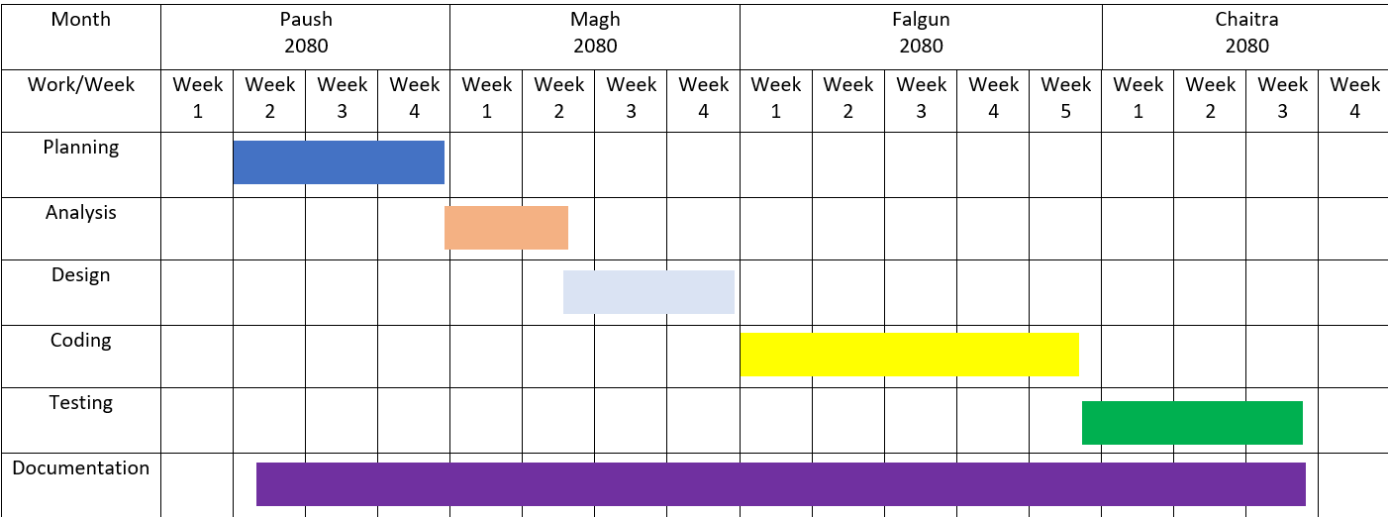

Figure 2 Gantt Chart of OMSP

## 3.2.3. System Design

The system design of Online Music Streaming Platform consists of architectural design, database schema design, interface design and DFD.

## 3.2.1. Architectural Design

The system architecture consists of three major parts namely Graphical User Interface (GUI), front end and back end. The architecture displays the basic process flow. GUI is the interface visible to the user/customer. A GUI allows the use of icons or other visual indicators to interact with electronic devices; rather than using only text via the command line. It display the different categories of grocery items, sign in, register etc. PHP & Xampp server are used as front-end technologies. When user clicks on the particular product, the query goes to the front end part. After that front end fetches the required data from the database i.e. Back end. The results are returned to front end and from there, to GUI for displaying. There is a database in the back end. It contains all the information regarding customers, products and vendors. Here, MySQL is used for this purpose. When user fires a particular query, the query is given to database and the corresponding result is segregated from large volume of information.

The following figure shows the archetictural design of OMSP system

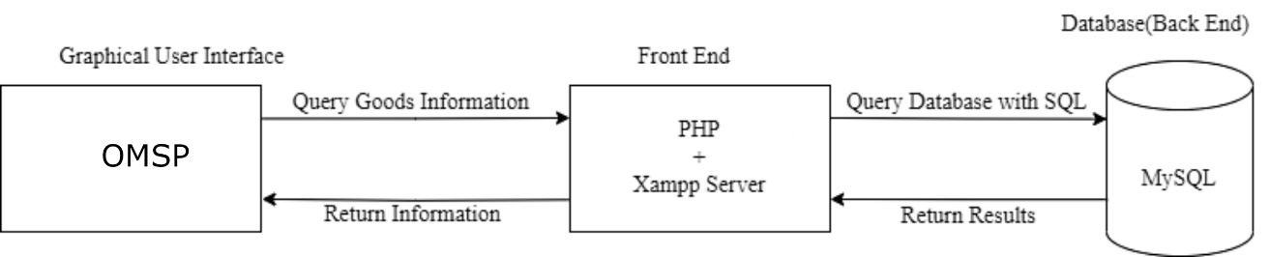

Figure 3 Architectural Design of OMSP

## 3.2.2. Database Schema Design

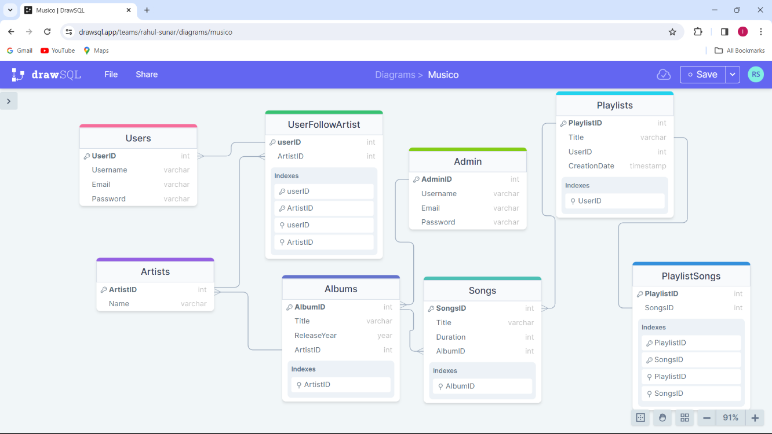The following figure shows the database design of Online Music Streaming Platform.

Figure 4 Database Schema Design of OMSP

3.2.4. Interface Design (UI Interface / Interface Structure Diagrams)Index Login Page:

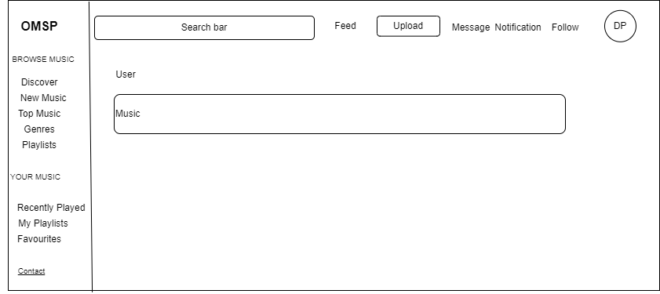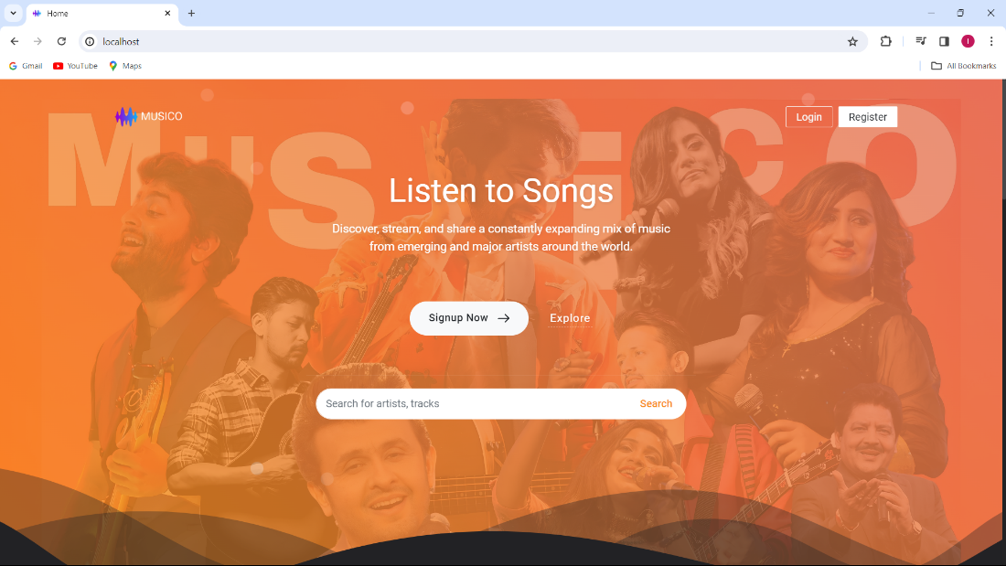

Figure 5 Homepage

Figure 6 Index Login Page of OMSP

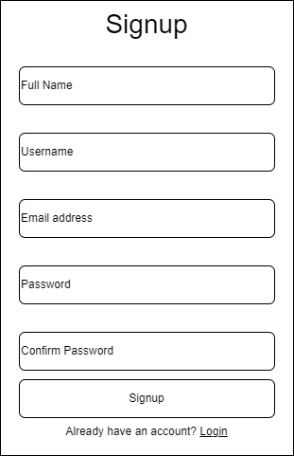Login Page: Register Page:

Figure 7 Login form

## 3.2.5. Data Modeling using ER Diagram

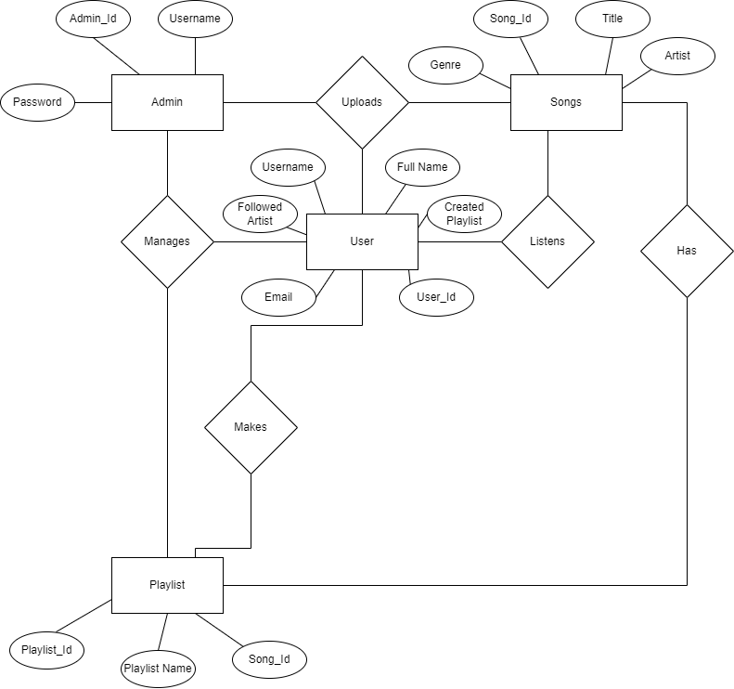This model shows entities, relationships between entities, mapping and the entity relationship models.

Figure 8 ER Diagram of Music Streaming Site

## 3.2.6. Process Modeling using DFD

This model identifies the flow of data between the system and external entities.

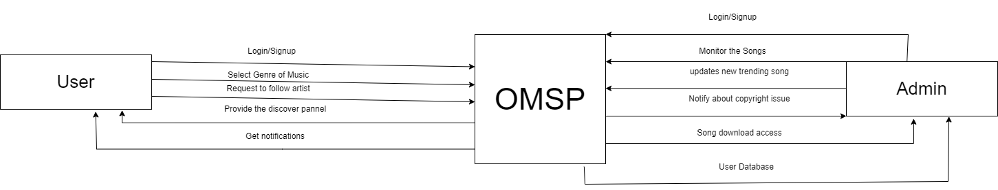

Figure 9 Level 0 dfd of Music Streaming Site

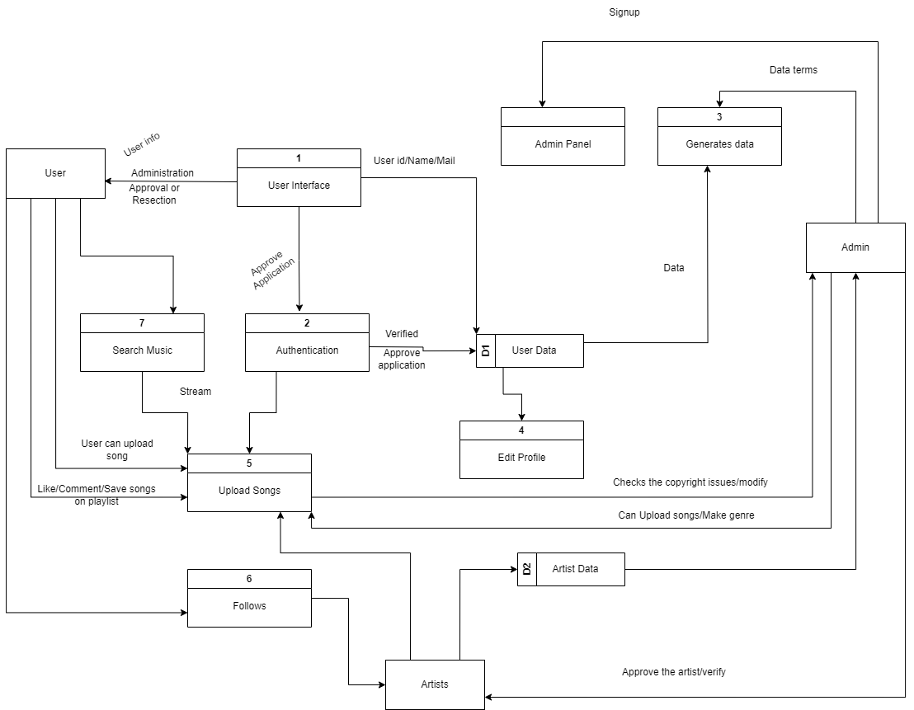The following figure shows the level 1 DFD of OMSP.

Figure 10 Level 1 DFD of OMSP

## 3.2.7. Physical DFD

# Chapter 4: Implementation and Testing

## 4.1. Implementation

The implementation phase involves the application of design specifications done before.

The implementation involves coding of the system designs if this project, systems testing are live running. During implementation we start coding according to our requirement.

## 4.1.1. Tool Used

**Diagram Tool:**

The designs used in this project are all made with help of “draw.io” . It is an online diagramming tool that allows to create various types of diagram and charts. It has a wide range of prebuilt shapes and icons that can be used to create custom layout and design. The tool also offers drag-and-drop interface.

**Web Application Development Tool:**

**HTML:**

HTML(Hypertext Markup Language) is a standard markup language used for creating and structuring the content of web pages. HTML has been used to design the frontend of webpages.

**CSS:**

CSS(Cascading Style Sheets) is a style sheet language used to describe the presentation and formatting of HTML(and XML) documents. The styling to the web page is done using CSS.

**PHP:**

PHP(Hypertext Preprocessor) is a popular server-side scripting language. It is used for building dynamic websites and web applications.

**MySQL:**

MySQL is an open-source relational database management system used for storing and managing structured data. It is based on the structured query language. With the help of MySQL, we can perform CRUD operations.

**Visual Studio Code:**

Visual Studio Code is a source code editor. Different programming language are readily available thus making the coding process faster and hassle free.

## 4.1.2. Implementation Details of Modules

**User Registration:**

Users have to register into the system before they login into the system. User is required to fill the registration from with text boxes.

**Stream Music:**

Any user logged in into the system can stream and like music.

**Upload Music:**

Any user logged in into the system and admin can upload their music with music’s title, cover art and description.

**Make Playlist:**

Any user logged in into the system and admin can make playlist consisting of various music.

**User Logout:**

User can logout of the system as per their choice.

## 4.2. Testing

The testing is performed to verify and validate the Online Music Streaming Platform. The presented system is tested to see if it is working properly with no error and if it fulfils the necessary requirement.

## 4.2.1 Test Case for Unit Testing

It is performed to determine if there are any issues and its main aim is to identify, analyze and fix the found defects.

**Testing Sign Up:**

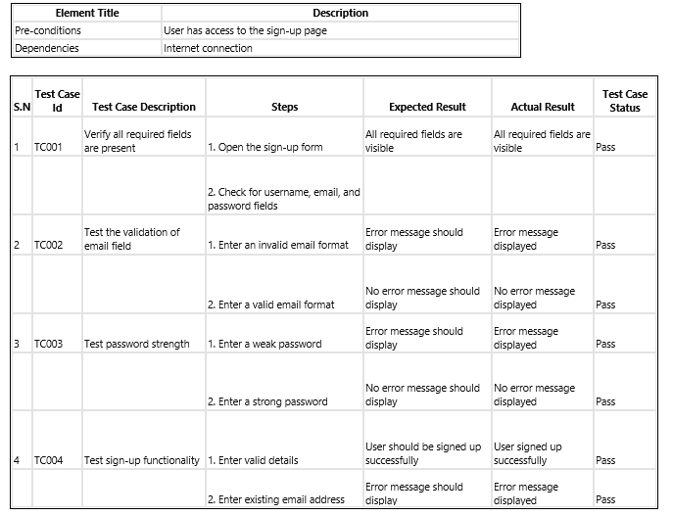

**Testing Music Play:**

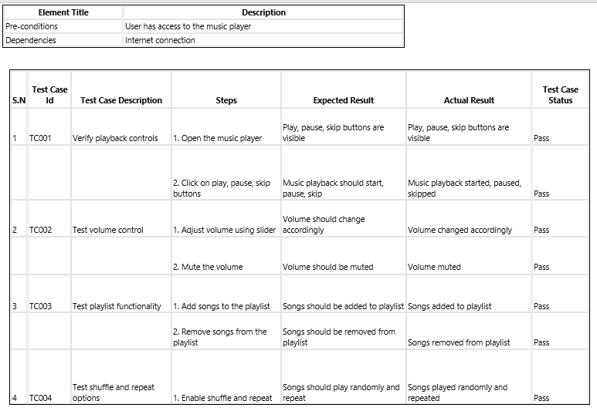

# Conclusion

In conclusion, the literature review on online music streaming platforms provides valuable insights into the multifaceted nature of these platforms and their impact on the digital music ecosystem. Through the examination of existing platforms such as Spotify, Apple Music, and YouTube Music, key themes emerge, highlighting the importance of user experience, technological innovation, and effective monetization strategies.

User experience emerges as a central consideration, with research emphasizing the significance of intuitive interfaces, seamless navigation, and interactive features in enhancing user satisfaction and engagement. Technological advancements play a pivotal role in shaping the evolution of online music streaming, enabling platforms to deliver high-quality audio streaming, minimize buffering times, and offer innovative features such as personalized recommendations and offline playback options.

Moreover, the literature underscores the importance of effective monetization strategies in sustaining the operations of online music streaming platforms. Subscription-based models, ad-supported tiers, and premium offerings are among the approaches adopted to generate revenue, with research highlighting the need to strike a balance between user value proposition and revenue generation.

Overall, the literature review underscores the dynamic nature of online music streaming platforms and the ongoing efforts to meet the evolving needs of music enthusiasts in an increasingly digital landscape. By understanding the key factors influencing user engagement, technological innovation, and monetization strategies, stakeholders can design and implement strategies to maximize the impact of online music streaming platforms and enrich the music listening experience for users worldwide.

# References

|  |  |
| --- | --- |
| [1] | Smith, J., & Johnson, A. , "The Impact of User Experience on Online Music Streaming Platforms," *Journal of Digital Media Studies,* pp. 45-88, 2019. |
| [2] | Brown, C., & Jones, M., "Designing User-friendly Interfaces for Music Streaming Platforms," *International Journal of Human-Computer Interaction,* pp. 321-335, 2018. |
| [3] | Lee, S., & Kim, D., "Technological Advancements in Online Music Streaming Platforms," *Journal of Information Technology Research,* pp. 87-102, 2020. |
| [4] | Patel, R., & Gupta, S., " Monetization Strategies in Online Music Streaming Platforms: A Comparative Analysis," *International Journal of Business and Management,* pp. 112-125, 2017. |